Potato Towers & Living Fence Posts!

When I was living in southern Mexico a few years back, there were many things that fascinated me about their methods of agriculture... it often displayed a simple, straight-forward and low energy/resource input methodology. One example of this that fascinated me to no end was the use of a specific type of tree (don't ask the species, I couldn't remember even if faced with a firing squad!), which they planted in the ground and used as fence posts. I remember one too many days as a child installing barb wire fences on our family farm, which required the use of excessive brute force and a pile driver, or a bobcat/tractor. In contrast, the low tech approach to creating a living fence post entailed sawing off a branch from a living tree, and sticking it in the ground. The branch would root itself out, and then the fence was attached to the very solid small tree. Eloquent indeed.
As I pondered the need to create fence posts on the Growing Lot site, I did not relish the idea of pounding metal stakes or rebar through the asphalt of the old parking lot. I turned it over in my mind, and like all good composting processes, it eventually produced black gold! I decided to create potato towers as living fence posts. This is a multi-functional element - and multi-functionality is a key component of Permaculture design. Not only does it act as a fence post, it allows me to grow a significant amount of food in a small space (think vertical!), and also add beauty. What is a potato tower you say, and how in the world do you make one? Well, follow me, and I will lead you down the proverbial rabbit hole to 'tater land...
Step 1: Resources - Here is a list of resources you should have on hand:
- 3 to 4' tall Wire fencing - something with sufficient gauge to retain its form, and be used for a few years,
- Wire cutters,
- Some sort of twisty tie or pliable metal,
- Straw or hay,
- Pure compost (no manure! not even composted!!),
- Water source,
- Potatoes (go for a mix, prettier that way),
Step 2: Create the frame
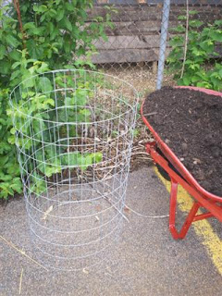
Use the wire cutters to cut out a section of the fence to create a cylinder container, about 2.5 to 3 ft in diameter. I personally find that a 4' tall, 14 gauge fence works well.
Use either a twisty tie, a piece of metal wire, or a pipe cleaner to tie the fence ends together.
The end product would look something like the bin to the left.
Then collect your compost. I tend to like a clean (meaning no rocks, plastics, etc.) leaf compost, which doesn't have a lot of large woody chunks.

3. Create the first layer
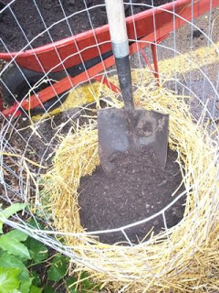
I personally like to use straw to create a barrier inside the bin to both help keep in the compost, and to reduce water-loss due to evaporation. Though it can be done without the straw, just make sure to use a fence with smaller holes to keep the compost from spilling out.
I first lay down a 2-3" layer of straw on the bottom then create a 'bird nest' inside the bin. The straw naturally supports itself up the sides as you spread it, leaving a large central area for the compost.
Next, shovel in the compost. I aim to put in my first layer of potatoes about 1 ft above the ground, allowing the bottom layer of potatoes plenty of room to form potatoes.
Step 4: Lay-down potato layer and water in... thoroughly!

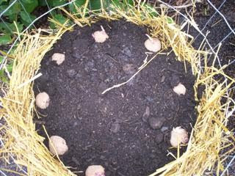
Lay the potatoes about every 5-6" along the very outside of the bin. They can be literally right next to the straw layer, with the eyes pointed out. (See picture to left for an idea.)
-----------------------------------------------------
A note about potatoes:
Use certified seed potatoes if possible... they are guaranteed disease free. Though, I have personally used potatoes from the previous year, and even from the store, and had great success. Though it's a little like playing Russian (..er Irish) Roulette.
Potatoes only need 1-2 eyes per piece to grow, so feel free to cut up the larger potatoes into 2 or more chunks, at least as big as a golf ball. The smaller potatoes can be simply planted whole. Ideally, cut the potatoes 24 hrs prior to planting, allowing time for a scab to grow over the cut, thereby reducing disease/rot issues. Though as a child, we would always cut and plant on the spot, and I always remember having to dig a lot of potatoes in the late summer...(where were those child labor laws when you really needed them??)
If the potatoes are already sprouting, no worries. If the sprouts are less than 3-4" long, go ahead and plant them. Or you can simply break off the sprouts, as they will regrow. You can actually do this up to 5 times before you start affecting the potatoes ability to grow. Resilient little suckers for sure!

Next, it is important to absolutely soak the compost, as it often is on the drier side of things. Do this after every potato layer is planted.
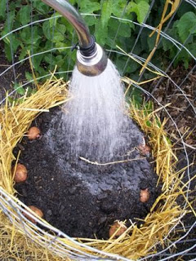
Step 5: Repeat steps 3 and 4, laying down a new layer of potatoes every foot or so until finished. The whole bin will use about 4 lbs. of potatoes.

Step 6: Toppin' er off...
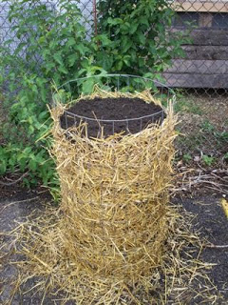
There are a couple options for finishing off the potato tower. You can finish it off with a top layer of potatoes (with about 5" of compost laying over-top) along both the outside and also an inner circle (these will sprout out the top of the bin - see image below).
Though I chose a different option at Growing Lots. I lay down 3 layers of potatoes along the outside (up to 3 ft), but then lay down a thick layer of straw and filled the top 1.5 ft with a soil/manure/compost blend for veggies. Then I planted a variety of plants into the top of each living fence post.
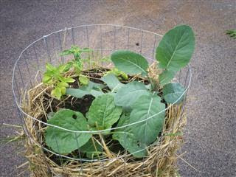

Step 7: Keep it well-watered...
It is important to keep the bin moist, from top to bottom. I have found the easy approach to watering is to create a moat along the top of the bin, and then put a hose in the moat at a flow-rate so that it is absorbed at about the same rate. Do this for about 20 minutes, once per week, and you should have sufficient moisture.
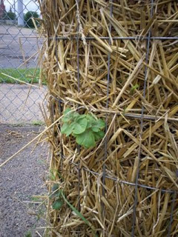
Step 8: grow, Grow, GROW!
In about 10-14 days you will see your first little potato shoots sprouting out the side of the potato tower.
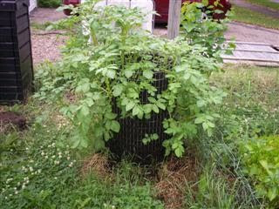

In about a month's time, the Potato Medusa is born! This picture is one of the potato towers planted through Backyard Harvest. You can see in this potato tower, we did not use straw, and simply used a fence with smaller holes.
Step 9: The Harvest
Once the potatoes have all died back in the late summer/fall, it's harvest time! No shovels, no digging.. simply tip over the potato bin and pick out the potatoes. Experience has shown that a bin that uses about 4 lbs of potatoes can produce upwards of 25 lbs of potatoes. Of course this will vary depending upon the potato variety chosen, and if any disease problems cut short the potato plants life.

Source: http://growinglots.blogspot.com/2010/06/potato-towers-living-fence-posts.html

